**Network Notes**

**Day 1**: Topologies/Scenarios



**Brief History:**

**DARPA: The Defense Advanced Research Projects Agency is a research and development agency of the United States Department of Defense responsible for the development of emerging technologies for use by the military.**

**Later on it became ARPA-NET**

How Different countries are connected via submarine-cables

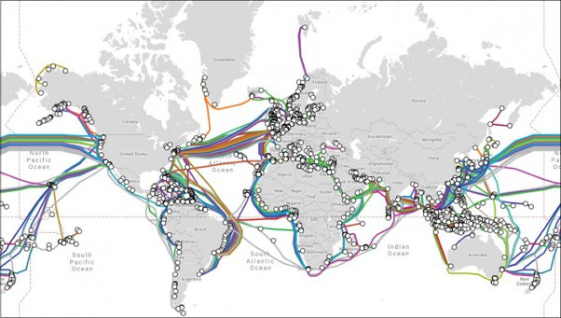

Important Terms

ISP: Bodies that provide internet connections. Can be of different categories

- Tier-I ISPs

- Tier-II ISPs

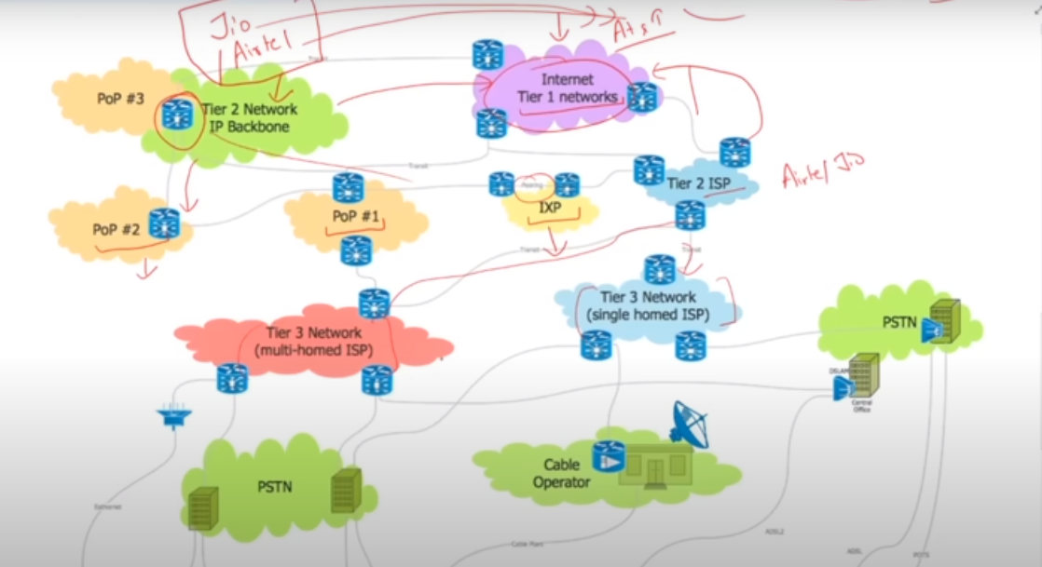

- Tier-III ISPs

Provides internet connection in different ways like

* DSL-connection
* Cable-net
* Wireless
* Dial-up-connection etc.

PUBLIC / INTERNET IP : Through which we connect to WAN

PRIVATE IP : IP that used in LAN cannot accessible to/from WAN directly

HUB : A hub is a basic networking device that connects multiple devices in a local area network (LAN) and forwards data to all connected devices.

SWITCH : A switch is a network device that connects devices within a local area network (LAN) and uses MAC addresses to forward data to the appropriate destination.

ROUTER : A device that connect different networks to each other

FIREWALL : A firewall is a network security device or software that monitors and controls incoming and outgoing network traffic based on predetermined security rules, helping to protect a computer or network from unauthorized access and cyber threats.

**Host : A host is a computer or device that stores and serves data, services, or resources to other devices on a network**

**Repeater: A repeater is a network device that amplifies and retransmits signals to extend the range and improve the quality of data transmission in a network.**

**Bridge: A bridge is a network device that connects and filters traffic between two or more network segments, making them function as a single network.**

NIC : A NIC (Network Interface Card) is a hardware component that enables a computer to connect to a network and communicate with other devices.

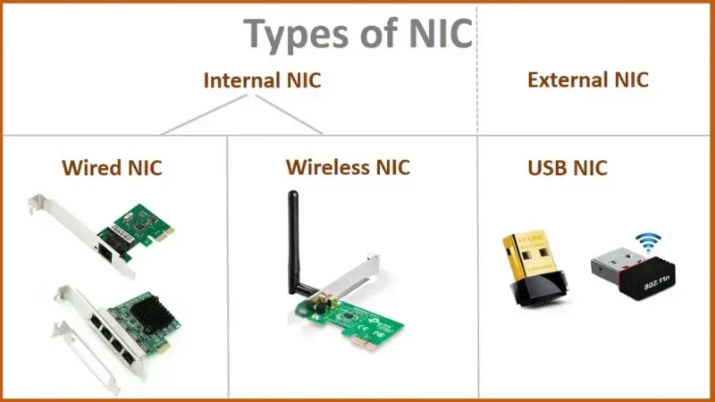

**Client-server connection:**

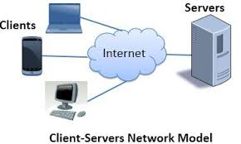

**Upload:** Sending request/data to server

**Download:** Receiving info/data from server e.g, streaming

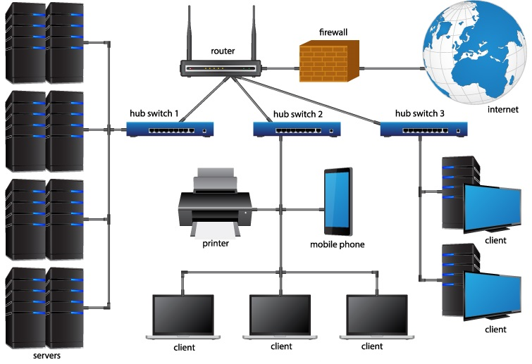

---------------------------------------------------------------------------

**HARDWARE, SOFTWARES AND FIRMWARE**

**Hardware:**

* A device that can be touched and feel.
* We cann’t change/update it’s shape.

**Firmware:**

* A kind of software binded with hardware at the time of hardware formation.
* Usually contains necessary instructions to use that hardware like how specific hardware is accessed and used.
* We can say at lower level firmware is an interface to specific hardware.
* Without firmware hardware is useless.
* Forexamlpe BIOS works as a firmware for motherboard/compueter.
* Now a days we can update but cannot remove or delete. Not accessible by user.

**Software:**

Set of instructions used to perform specific tasks. Categorize into two part

* **System Softwares:**

System software acts as the interface between the hardware and the user, for example

* OS
* Device Drivers
* Utilities

Mostly used for

* Resources Allocation
* Security
* Interface
* Hardware Management
* **Application Softwares:**

Application software, also known as "apps" or "programs," is designed to perform specific tasks or functions for end-users. For Example browsers, ms-word, book-readers etc.

----------------------------------------------------------------------------

**TRANSMISSION MODES**

* **Simplex e.g** TV/Radio Transmission
* **Half-Duplex** e.g. walki-talkie set
* **Full-Duplex-**(bandwidth is shared) e.g. telephone

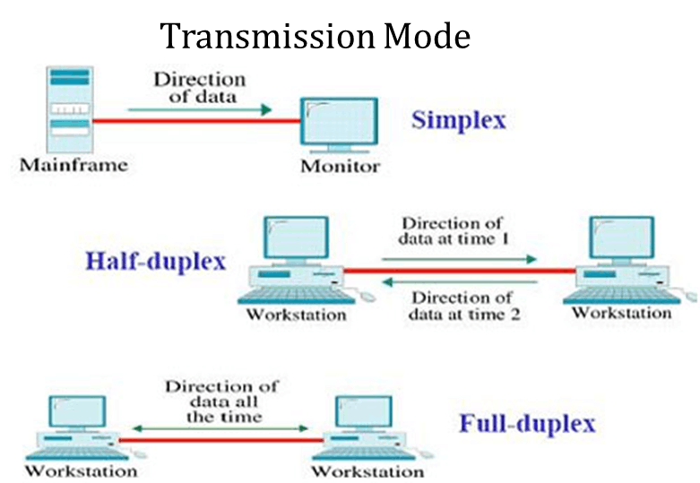

**_______________________________________**

**OSI**(Open system interconnection) **MODEL**

It’s a set of rules to govern communication through the internet. Actually it’s a reference model. Mostly we use TCP/IP over the internet for communication.

**7. APPLICATION Layer**

* This is Human interaction softwares like browser, ms-word, book-reader or music player etc.
* This layer uses many different protocols like HTTP, SMTP, FTP, TELNET protocols.

**6. PRESENTATION Layer**

* Presentation of data in respective formats like bases on file extension file is opened in respective application like music player, ms-word, browser etc

**5. SESSION Layer**

* Create and maintain the session e.g, banking sites
* Actually this layer is called end-to-end layer
* This layer establishes connection between source to destination and to communicate as well.
* The session layer establishes, manages, and terminates communication sessions between devices. It controls dialog coordination and synchronization.

**4. TRANSPORT Layer**

The transport layer ensures end-to-end communication between devices. It manages data **segmentation (**to make packets of whole data**)**, flow control, and error recovery. The two most common transport layer protocols are TCP (Transmission Control Protocol) and UDP (User Datagram Protocol).

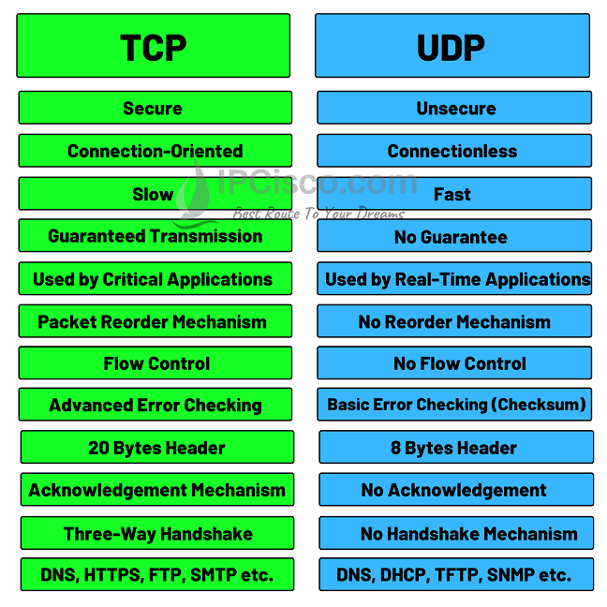

**3. NETWORK Layer**

This layer receives segmented data (packets) from the transport layer and adds source and destination ip-addresses to each segment and thus packets(contains src and dest ip-addresses) are ready to transfer to the next layer which is data-link layer.

So this layer provide actual route to follow from source to destination

**2. DATA-LINK Layer**

This layer further divide packets into small data frames and appends MAC-addresses to each frame. Frames are called if they contain source and destination MAC-address.

**1. PHYSICAL Layer**

Here all frames data is converted into bits (signals) and transferred through media(wireless or wired).

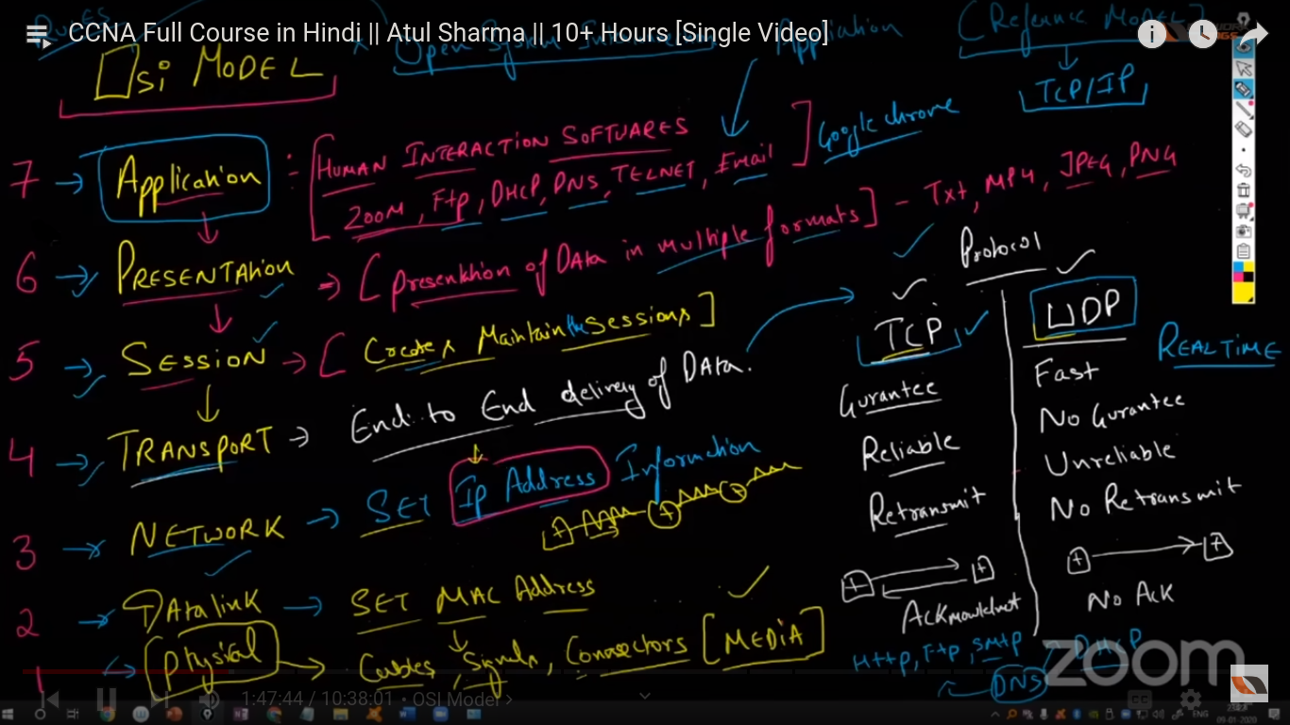

PDUs (Protocol Data Units) for each layer

DATA: s/w layers (Application, Presentation and Session)

SEGMENTATION: Transport Layer

PACKETS: Network Layer (IP addresses)

FRAMES: Data-Link layer (MAC-address)

BITs: Physical Layer

**LAN, MAN and WAN**

These are network types with respect to their geographical span. Here is more detail about each network.

LAN:

If communication between systems routes(spans) within local or restricted areas this network will be called local area network. Here are few main characteristic of LAN.

* Devices are directly connected instead of connecting through the internet.
* Mostly connected via cable (twisted pair or ethernet) and wifi
* For example two systems from one system to another system in different cities connected through a direct cable is an example of LAN.
* The faster and the most secure network.
* Mostly installed this kind of network for devices lying in a small area may be a lab or campus or home etc.

WAN:

If devices communicate via the internet irrespective of their locations. Like if two systems communicate via facebook or gmail within a room this will be WAN. Here are few characteristics of WAN

* This network is establish with fiber-optics
* Slower than LAN and MAN
* More vulnerable network
* Connected through routers.

MAN:

This is a kind of network like a company that has multiple offices at different places of a city or different cities, but they are directly connected to each other so this will be MAN.

Its characteristics lie between LAN and WAN.

## **Networking concepts in for DevOps (By Abhishek Vermala)**

### **IP Adreeses**

* Unique identifier of network devices
* Can be of one type (IPv4 or IPv6)
* IPv4 IP address is based on 32 bit(4-octets). Each octet range from 0-255 (28)
* IP can be public(accessible from internet) and private (cannot accessible from internet)

### **CIRD(Classless Inter-Domain Routing) or CIDR-range**

The number representing a subnet (small portion of a big network), shows IP address range for a perticular subnet for example

* 10.255.255.255 / 8 Class-A subnet can contain 256*256*256 IP addresses.
* 172.168.255.255 / 16 Class-B subnet can contain 256*256 IP address
* 192.159.113.255 / 24 Class-C subnet can contain maximum 256 IPs

Note: 📖

* Class-A private ip address start from 10 for example 10.44.22.11

**Range**: 10.0.0.0 to 10.255.255.255 (Subnet Mask: 10.0.0.0/8)

For larger networks

* Class-B private ip address start from 172 for example 172.99.0.111

**Range:** 172.16.0.0 to 172.31.255.255 (Subnet Mask: 255.255.0.0/16)

For medium size networks

* Class-C private ip address start from 192 for example 192.168.222.111

**Range:** 192.168.0.0 to 192.168.255.255 (Subnet Mask: 255.255.255.0 / 24)

#### **Subnet Mask:** A 32-bit number followed by ‘/’ and a number. This tell about total **number of hosts** can be in a subnet, **network part** (Part of a bigger network or internet) and **host part** (IPs in a subnet) for example

172.16.0.0/16.

**PORTs:** Specific interface represented by a unique number through which we access our website or any other service running on a particular system.

#### 

#### OSI Model

Bird-eye view of communication between internet Devices (client-server)

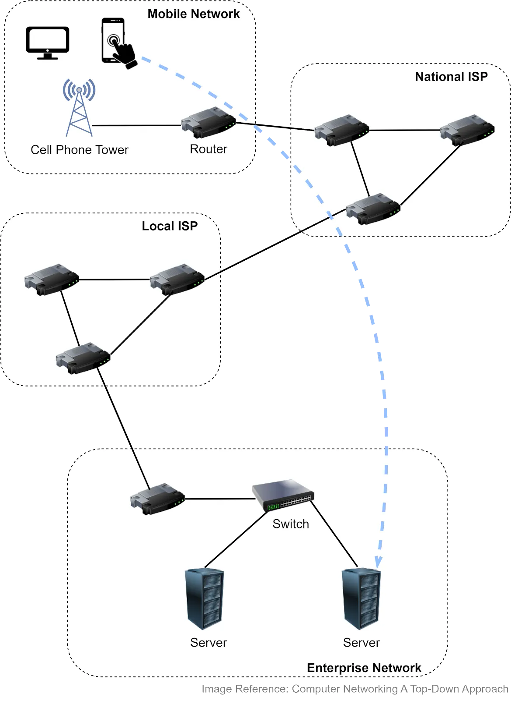

OSI MODEL

